Form 105 Issue 5
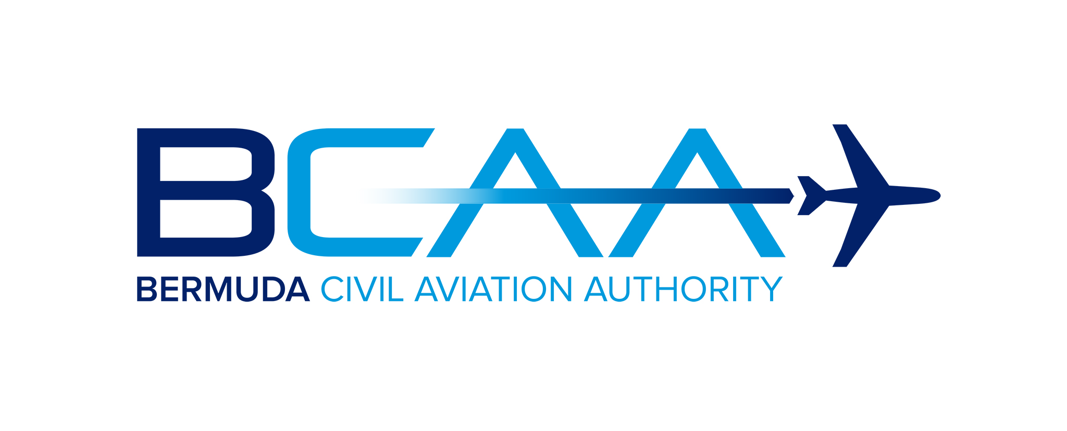
Checklist for Registering Private Aircraft
Including Airworthiness and Operational Approvals

To assist you through the process of placing a private aircraft on the Bermuda Register, please find below details of the requirements for aircraft registration, the initial issue of a Certificate of Airworthiness and Overseas Territories (OTs) Operational Approval.

1. To enable the registration processes to begin, submit completed signed copy of the Application for Registration of Aircraft or Change of Ownership (Form 100(B)) with applicable documentation. A representative from the registered owner or operator should be nominated to be the main point of contact with the registry throughout the process. The form will be reviewed by the Bermuda Civil Aviation Authority (BCAA) within a few days and it will be confirmed that the aircraft is eligible and the owner qualified for the aircraft to be registered in Bermuda.

2. Subsequently, steps 2 through to 9 can be completed as part of the registration process to permit BCAA to issue the Certificate of Registration.

3. The steps to be completed prior to issuance of a Certificate of Airworthiness are outlined in steps 10 through to 20 and this process can commence once the applicant has received the confirmation outlined in 1. above. A Nominated Airworthiness Technical Coordinator should be made available to enable the applicant to provide the related airworthiness coordination and documentation.

4. Various operational approvals will also be required as outlined in steps 21 through to 26 and this process can commence once the applicant has received the confirmation outlined in 1. above. As the operational approval will require some period of time to complete, BCAA will issue an interim approval valid for up to 6 months. An appropriately knowledgeable and qualified Flight Operations representative should be made available to enable the applicant to provide the related flight operations coordination and documentation.

5. Processes outlined in 2., 3., 4. above will run concurrently. Please submit all applications electronically. Paper copies are not required. A summary of each step of the process follows as well as a link to the appropriate form if applicable.

6. The Air Navigation (Overseas Territory) Order 2013 (AN(OT)O) has been promulgated and sets out the provisions to enable Bermuda (United Kingdom) to comply with the ICAO Convention and in particular the Annexes to that Convention in the OTs. The OTARs are the Overseas Territories Aviation Requirements and these provide the means of compliance with the rules and regulations in the AN(OT)O. The applicable OTARS are included in the checklist as applicable.

Checklist

BCAA Initial Application Stage
1 |  | Application for Registration of Aircraft or Change of Ownership (Form 100B)  Once the Form 100B has been completed, BCAA will be able to confirm to the applicant that the aircraft is eligible and the person or corporation qualified to have an aircraft registered in Bermuda. If an applicant would require special marks they should make the request when submitting the Form 100B.
Prior to Issue of a Certificate of Registration – Reference OTAR 47
2 |  | Power of Attorney (if applicable)  Required if a person or persons will be signing applications on behalf of the registered owner of the aircraft.
3 |  | Affidavit or Certified True Copies of the Bill of Sale (Proof of Ownership) AND/OR Lease Agreement where the registered owner is a Charterer by Demise.
4 |  | Certified True Copies of the Certificate of Incorporation and List of Company Directors.
5 |  | Priority Mortgage (if applicable)  Once accepted the Priority Notice is valid for fourteen working days. To maintain priority, the contemplated mortgage must be made and entered in the Mortgage Register or further Priority Notice entered within the fourteen day period.
6 |  | Deregistration OR Certificate of Non-Registration document received from the previous State of Registry.
7 |  | Certificate of Registration is issued
8 |  | Registration of Mortgage (if required)  Once the Mortgage document is received by BCAA an entry will be made on the appropriate Aircraft or Engine Mortgage Register.
9 |  | Registration of an Irrevocable De-registration and Export Request Authorisation” (IDERA) (if required)  Information concerning establishment of an IDERA can be found on the BCAA website - https://www.bcaa.bm/guidance-application-cape-town-convention-bermuda.
Airworthiness Applications and Required Documents – Reference OTAR 21, 36, 39, 43
10 |  | Application for the Issue of a Certificate of Airworthiness Form AW-200
11 |  | Arrangements for Continued Airworthiness Management  The holder of an air operator's certificate or the owner or operator of an aircraft above 2,700 kg MTOW must have arrangements for continued airworthiness management. The Continued Airworthiness Management Organisation (CAMO) must be BCAA approved under the requirements of OTAR 39 Subpart E. The operator may seek approval themselves or contract a separate CAMO. The operator should make arrangements for the management of their aircraft in the early stages of the registration process and inform the BCAA of those arrangements.
12 |  | Recommendation for the Initial Issue of a Certificate of Airworthiness Form AW-201(I)  This form is to be completed and submitted by the Operator's Continued Airworthiness Management Organisation (CAMO) along with the required supporting documentation.
13 |  | Maintenance Programme  All aircraft on the Bermuda register must be maintained in accordance with a BCAA approved maintenance programme. To apply for approval the applicant should submit a copy of the maintenance programme along with the Aircraft Maintenance Programme Approval Application Form AW-285 and OTAR 39 Maintenance Programme Compliance Checklist Form AW-287.
14 |  | Export Certificate of Airworthiness  The applicant should provide a copy of the Export Certificate of Airworthiness issued by the last state of registry. The Export Certificate of Airworthiness must be issued within 60 days of the Certificate of Airworthiness application.
15 |  | Application for a Noise Certificate Form AW-268
16 |  | Declaration of Flight Manual Supplements Form AW-235
17 |  | Nationality and Registration Markings  The aircraft must display Nationality and Registration markings on the lower left hand wing and on both sides of the fuselage or on the upper halves of the vertical tail. The Aircraft Marking requirements are found in OTAR Part 47.
18 |  | ELT Registration  At least one ELT 406Mhz must be installed and registered with the Bermuda Maritime Operations Centre (RCC Bermuda) (http://www.rccbermuda.bm/).
19 |  | Mode S Transponder  The Mode S code will be provided by BCAA and the transponder must be programmed with this code.
20 |  | Class Six Radio License  The applicant must apply to the Bermuda Regulatory Authority for a Class Six Radio License (https://www.ra.bm/electronic-communications-licences-radio-licences/).
Operations Applications and Approvals – Reference OTAR 91, 92, 125
21 |  | Non Commercial Complex Aircraft Approval - OTAR 125 Form 9019  All operators who fall within the applicability of OTAR 125 require BCAA Approval. Guidance material is to be found in OTAR Part 91 and 125, plus a “New Operator” package on the BCAA website
22 |  | Airspace Approvals Form 9531  Applications for all Airspace Approvals to include, but not limited to, RVSM, MNPS, RNP, RNAV, ADS and CPDLC can be sought by completing the application and submitting the required supporting documentation. Further guidance on North Atlantic Operations can be sourced on the BCAA website .
23 |  | Minimum Equipment List Approval Form 9006  Application form and guidance on producing a Bermuda compliant MEL can be found on the BCAA website.
24 |  | Flight Crew Licence Validations Form 9511  Application and further guidance and information can be found on the BCAA website. The BCAA will validate licences/certificates issued from the majority of ICAO Contracting States.
25 |  | Required Aircraft Equipment – OTAR Part 125  Operations Form 9017A, should be completed by the Operator to provide a concise and itemized list of required equipment, as outlined in OTAR Part 125 subpart F, for each aircraft to be operated. Contact Flight Operations at flightops@bcaa.bm.
26 |  | Special approvals – Low Visibility Operations (LVO), Electronic Flight Bag (EFB), Steep approaches, (if required)  Information on these approvals can be found on the BCAA website.
Accounts
27 |  | Complete New Customer/Name Change Finance Form if applicable.  Forward to receivables@bcaa.bm.

